**Setting up your Iphone App**

1. First of all, download the App and open it.
2. 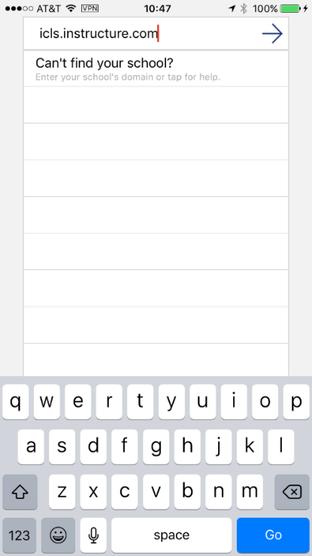In the’search’ box, enter icls.instructure.com and click on ‘Go’ or the arrow…
3. 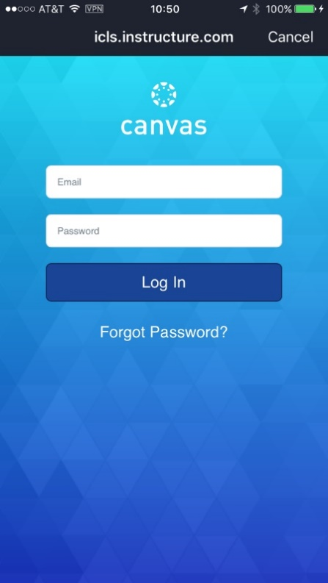You should then arrive at the page below, where you can enter your email address and PW.